Test Case: tc005_SPX_Dev5_Crear_Requisicion_Spot_Con_FAD_Tipo_Cobro_Project
Step 1 - Enter username and password and click to button Enter: Credentials Entered
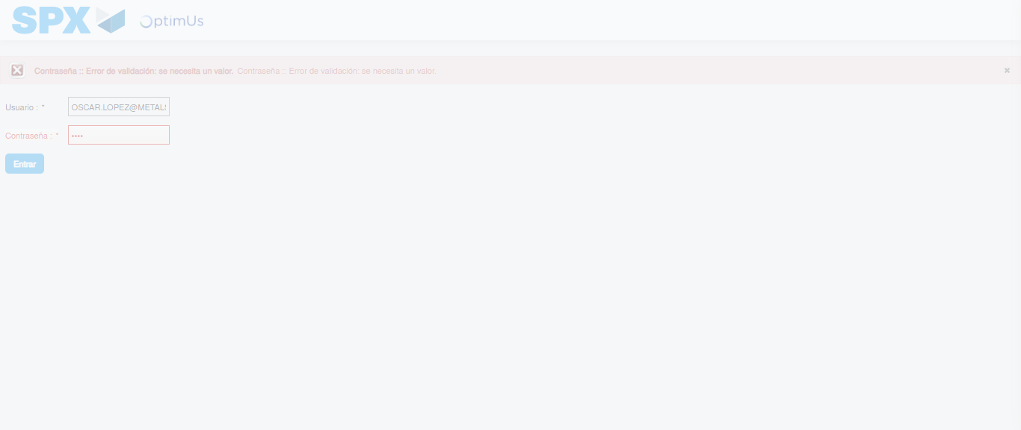Image file-name: QC_Testing-tc005_SPX_Dev5_Crear_Requisicion_Spot_Con_FAD_Tipo_Cobro_Project-1784653004383

Step 2 - Select to UEN and Access to Spot Buy Requisitions : UEN Correctly selected and Correct access
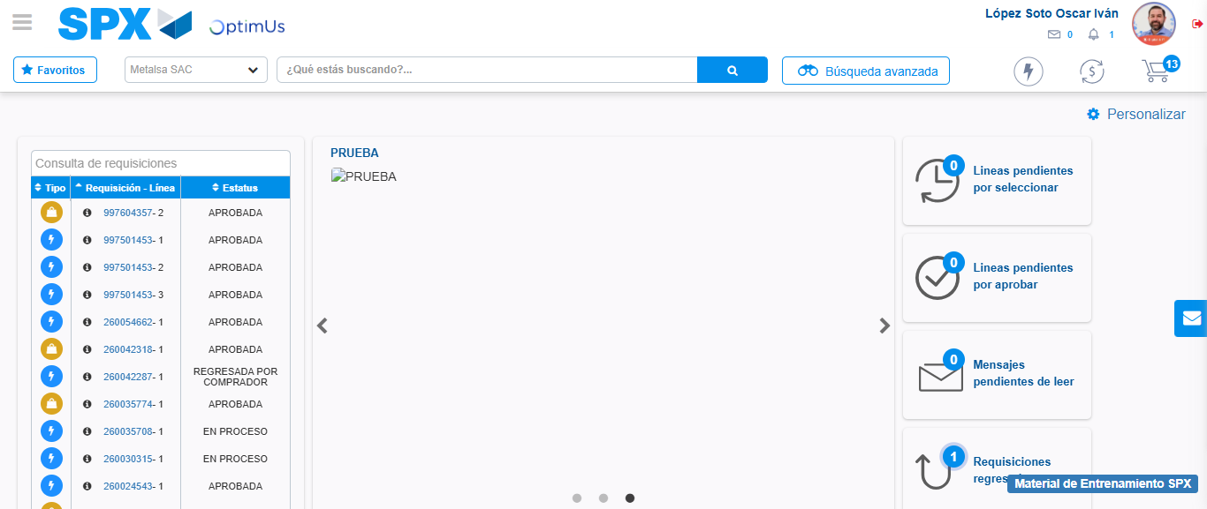Image file-name: QC_Testing-tc005_SPX_Dev5_Crear_Requisicion_Spot_Con_FAD_Tipo_Cobro_Project-1784653074969

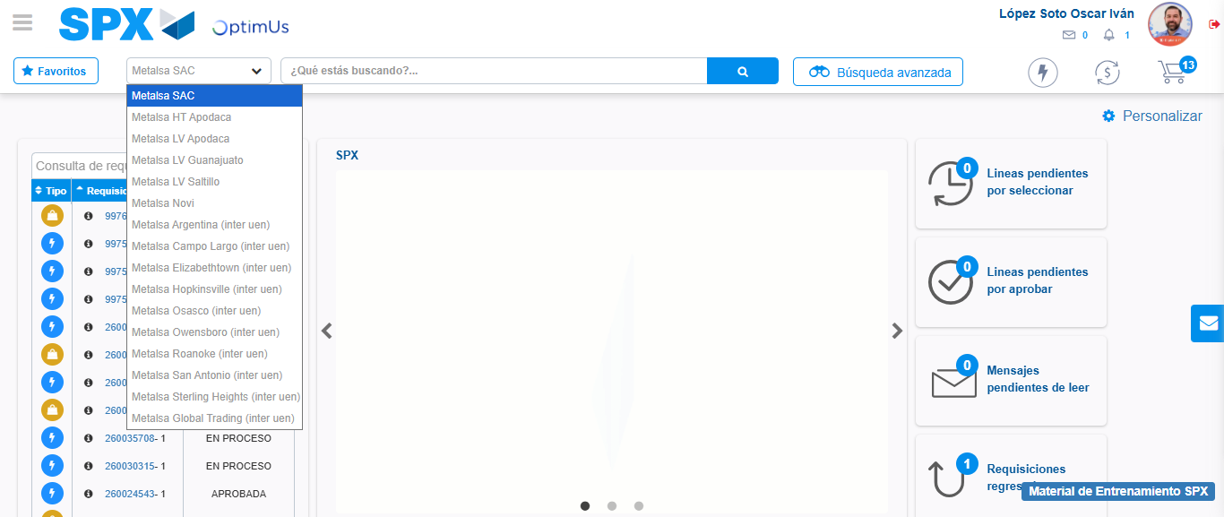Image file-name: QC_Testing-tc005_SPX_Dev5_Crear_Requisicion_Spot_Con_FAD_Tipo_Cobro_Project-1784653077799

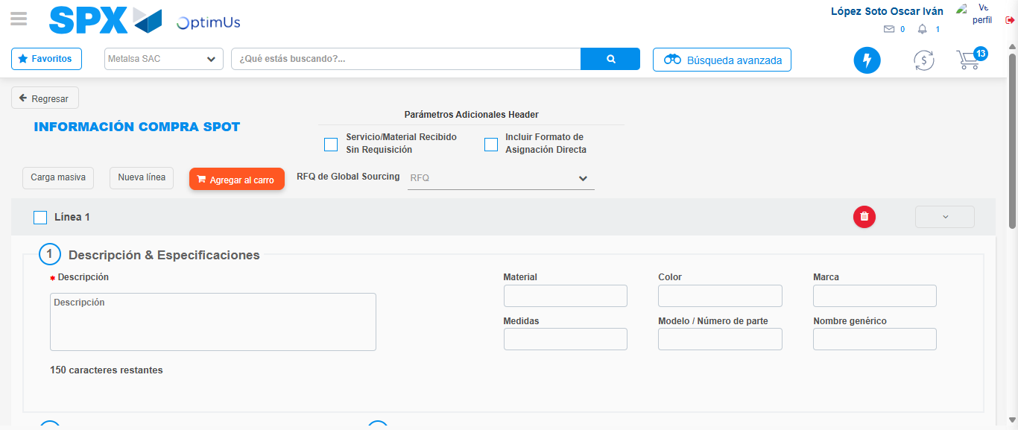Image file-name: QC_Testing-tc005_SPX_Dev5_Crear_Requisicion_Spot_Con_FAD_Tipo_Cobro_Project-1784653084901

Step 3 - Add FAD to Requisition: FAD Successfully Added
Image file-name: QC_Testing-tc005_SPX_Dev5_Crear_Requisicion_Spot_Con_FAD_Tipo_Cobro_Project-1784653085132

Image file-name: QC_Testing-tc005_SPX_Dev5_Crear_Requisicion_Spot_Con_FAD_Tipo_Cobro_Project-1784653085338

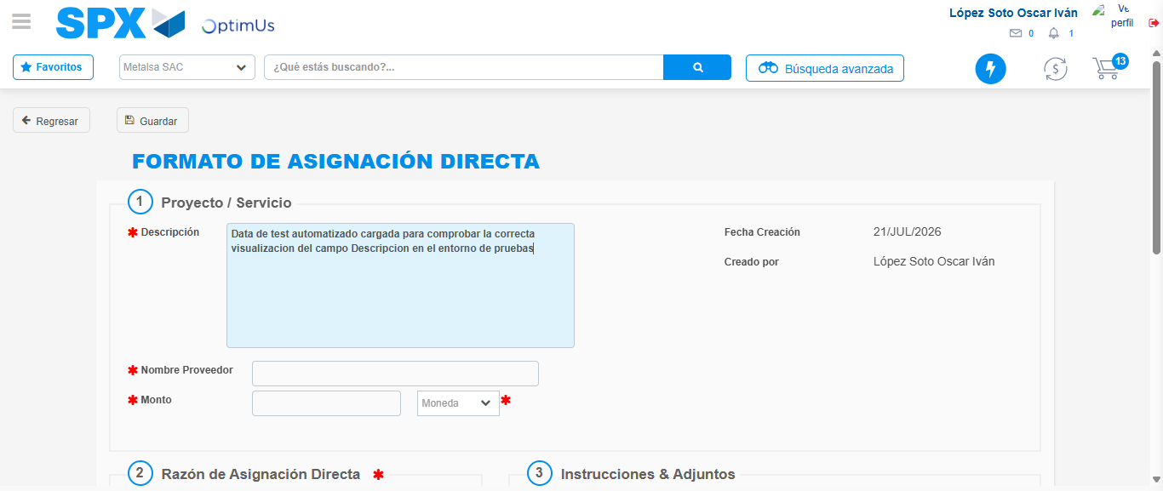Image file-name: QC_Testing-tc005_SPX_Dev5_Crear_Requisicion_Spot_Con_FAD_Tipo_Cobro_Project-1784653088224

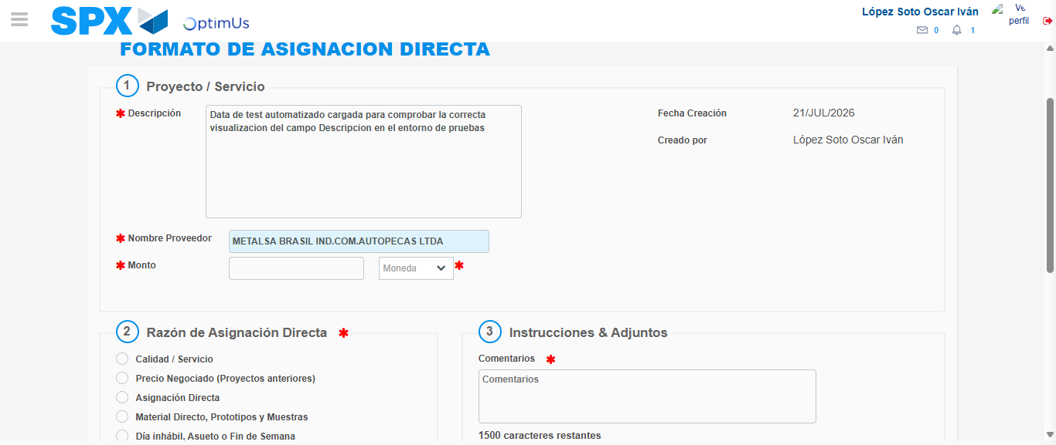Image file-name: QC_Testing-tc005_SPX_Dev5_Crear_Requisicion_Spot_Con_FAD_Tipo_Cobro_Project-1784653094522

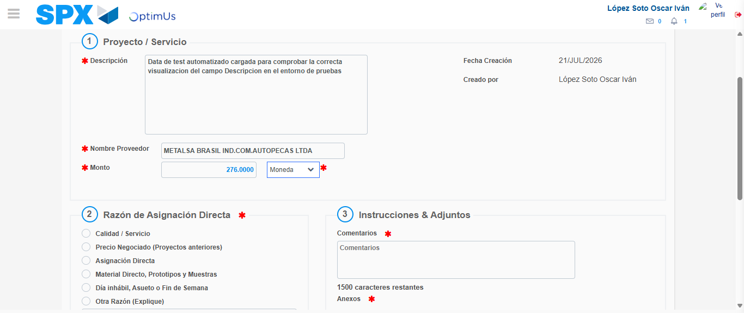Image file-name: QC_Testing-tc005_SPX_Dev5_Crear_Requisicion_Spot_Con_FAD_Tipo_Cobro_Project-1784653095068

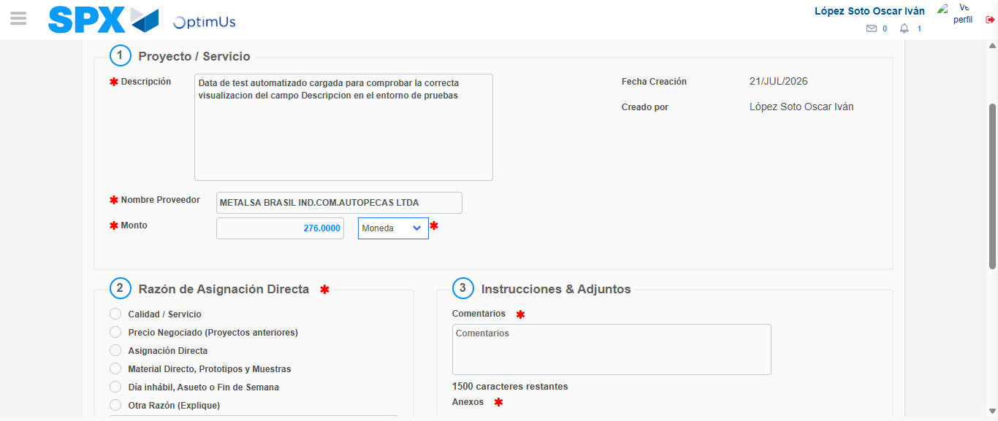Image file-name: QC_Testing-tc005_SPX_Dev5_Crear_Requisicion_Spot_Con_FAD_Tipo_Cobro_Project-1784653095306

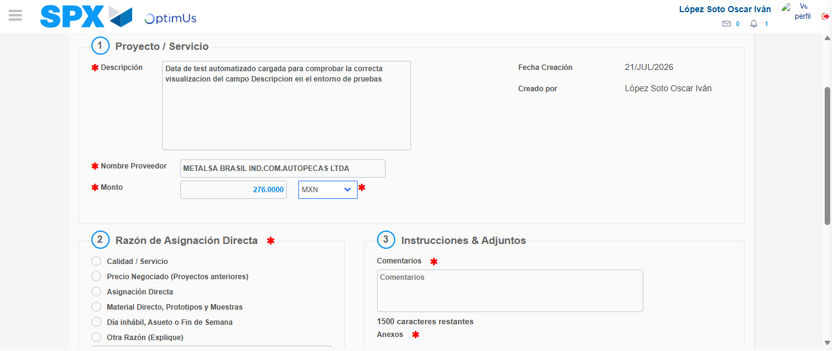Image file-name: QC_Testing-tc005_SPX_Dev5_Crear_Requisicion_Spot_Con_FAD_Tipo_Cobro_Project-1784653095705

Image file-name: QC_Testing-tc005_SPX_Dev5_Crear_Requisicion_Spot_Con_FAD_Tipo_Cobro_Project-1784653095890

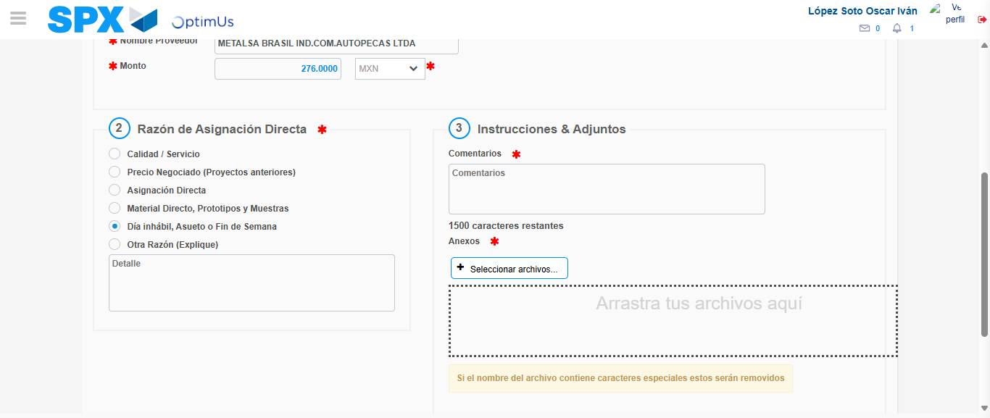Image file-name: QC_Testing-tc005_SPX_Dev5_Crear_Requisicion_Spot_Con_FAD_Tipo_Cobro_Project-1784653096775

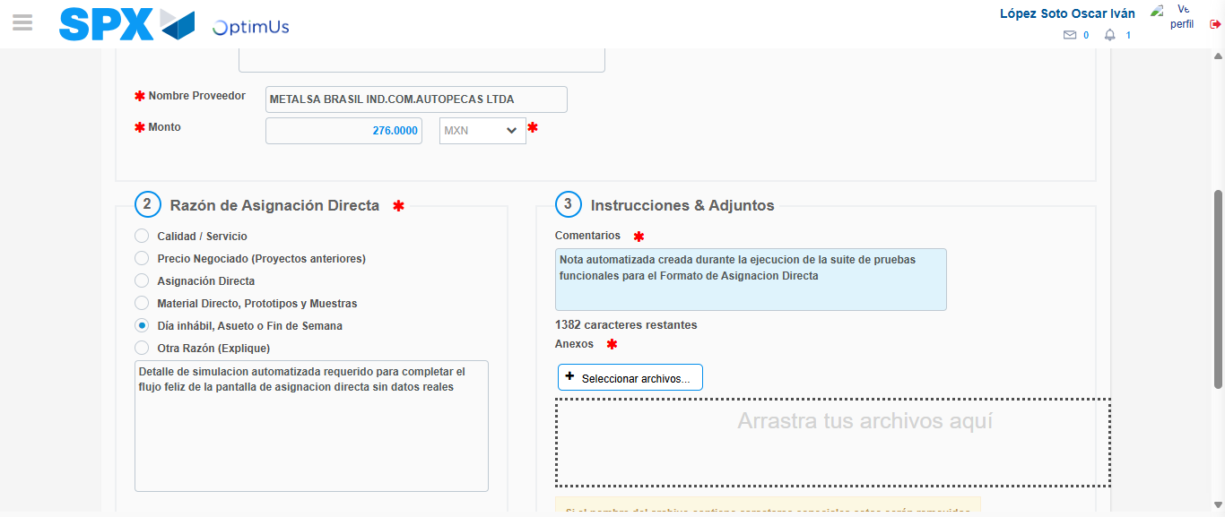Image file-name: QC_Testing-tc005_SPX_Dev5_Crear_Requisicion_Spot_Con_FAD_Tipo_Cobro_Project-1784653108083

Image file-name: QC_Testing-tc005_SPX_Dev5_Crear_Requisicion_Spot_Con_FAD_Tipo_Cobro_Project-1784653108811

Step 4 - Data Capture Spot Buy Requisition: Data captured correctly
Image file-name: QC_Testing-tc005_SPX_Dev5_Crear_Requisicion_Spot_Con_FAD_Tipo_Cobro_Project-1784653085132

Image file-name: QC_Testing-tc005_SPX_Dev5_Crear_Requisicion_Spot_Con_FAD_Tipo_Cobro_Project-1784653085338

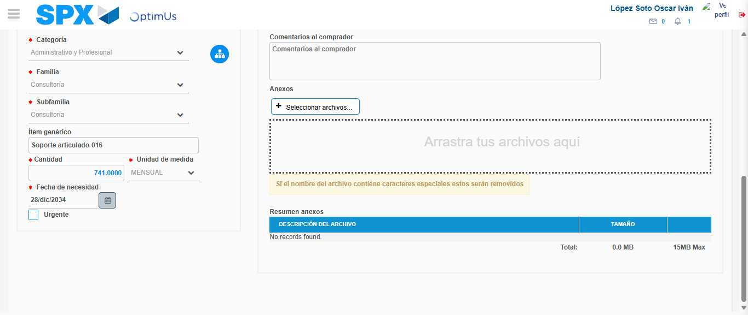Image file-name: QC_Testing-tc005_SPX_Dev5_Crear_Requisicion_Spot_Con_FAD_Tipo_Cobro_Project-1784653121951

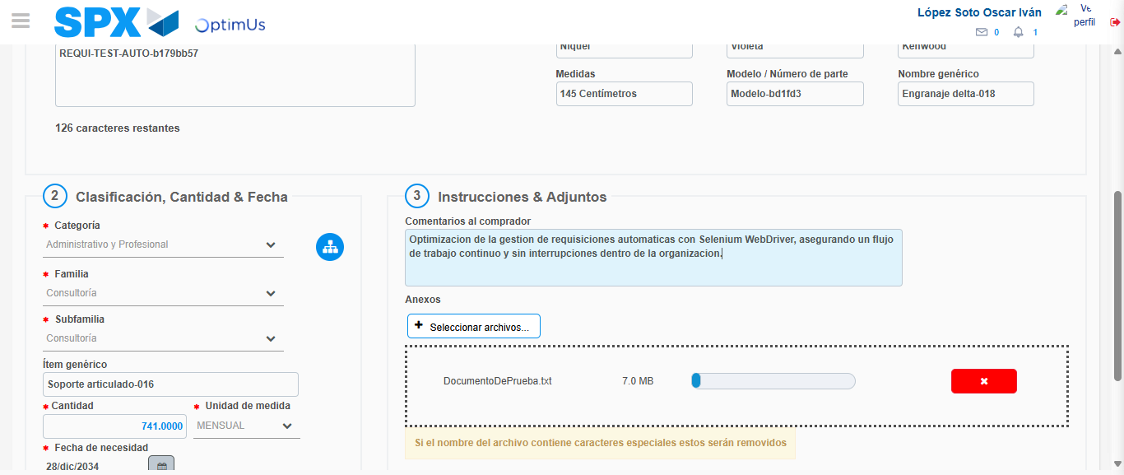Image file-name: QC_Testing-tc005_SPX_Dev5_Crear_Requisicion_Spot_Con_FAD_Tipo_Cobro_Project-1784653122951

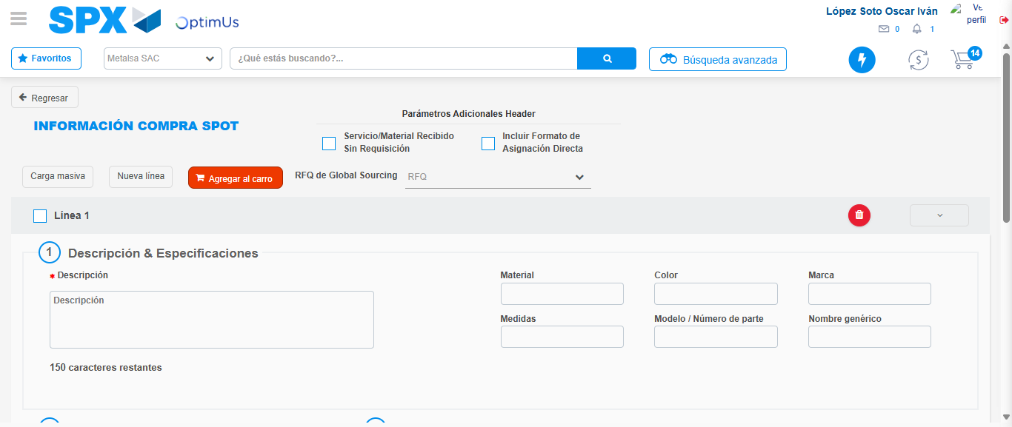Image file-name: QC_Testing-tc005_SPX_Dev5_Crear_Requisicion_Spot_Con_FAD_Tipo_Cobro_Project-1784653130655

Step 8 - Return to Main Page SPX : Return to Main Page SPX
Image file-name: QC_Testing-tc005_SPX_Dev5_Crear_Requisicion_Spot_Con_FAD_Tipo_Cobro_Project-1784653074969

Image file-name: QC_Testing-tc005_SPX_Dev5_Crear_Requisicion_Spot_Con_FAD_Tipo_Cobro_Project-1784653077799

Image file-name: QC_Testing-tc005_SPX_Dev5_Crear_Requisicion_Spot_Con_FAD_Tipo_Cobro_Project-1784653084901

Image file-name: QC_Testing-tc005_SPX_Dev5_Crear_Requisicion_Spot_Con_FAD_Tipo_Cobro_Project-1784653132946

Image file-name: QC_Testing-tc005_SPX_Dev5_Crear_Requisicion_Spot_Con_FAD_Tipo_Cobro_Project-1784653133164

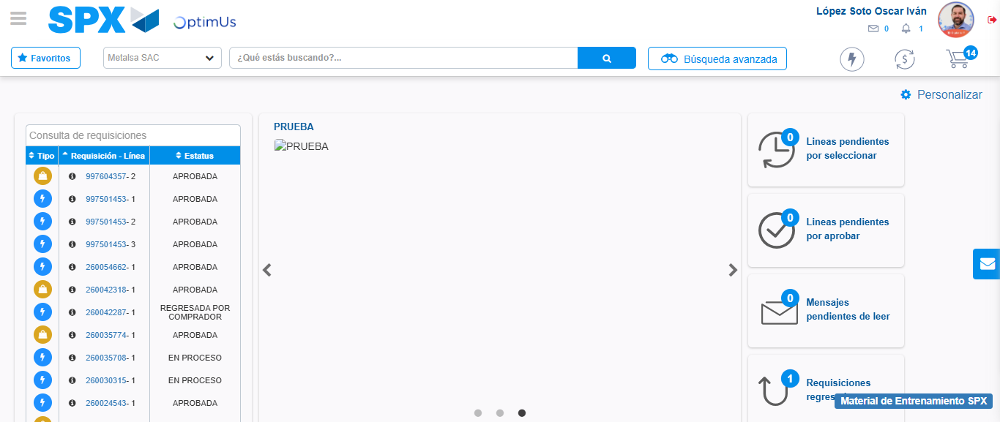Image file-name: QC_Testing-tc005_SPX_Dev5_Crear_Requisicion_Spot_Con_FAD_Tipo_Cobro_Project-1784653154274

Step 9 - Log Out : Log Out SPX
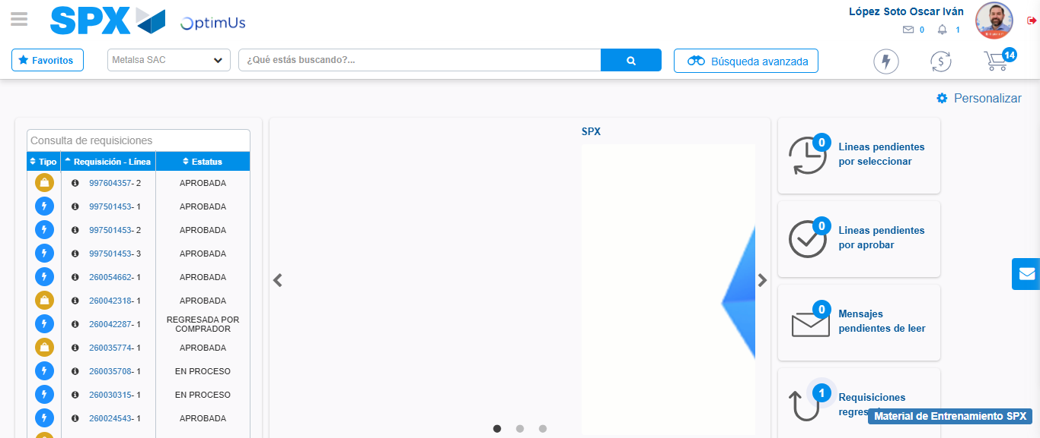Image file-name: QC_Testing-tc005_SPX_Dev5_Crear_Requisicion_Spot_Con_FAD_Tipo_Cobro_Project-1784653154623

